Neighbourhood Easter Egg Hunt

Easter is a great time to engage in outreach as a congregation. Inviting the families in your neighbourhood to participate in an Easter egg hunt is a fun way to share God’s love through hospitality.

Invitations and/or Posters
Create colourful and fun invitations to the Easter egg hunt. If possible, have members of your children’s ministry decorate the invitations and deliver them to the houses surrounding your church. If you can accommodate large numbers, also make posters and hang them in highly visible places around your neighbourhood.

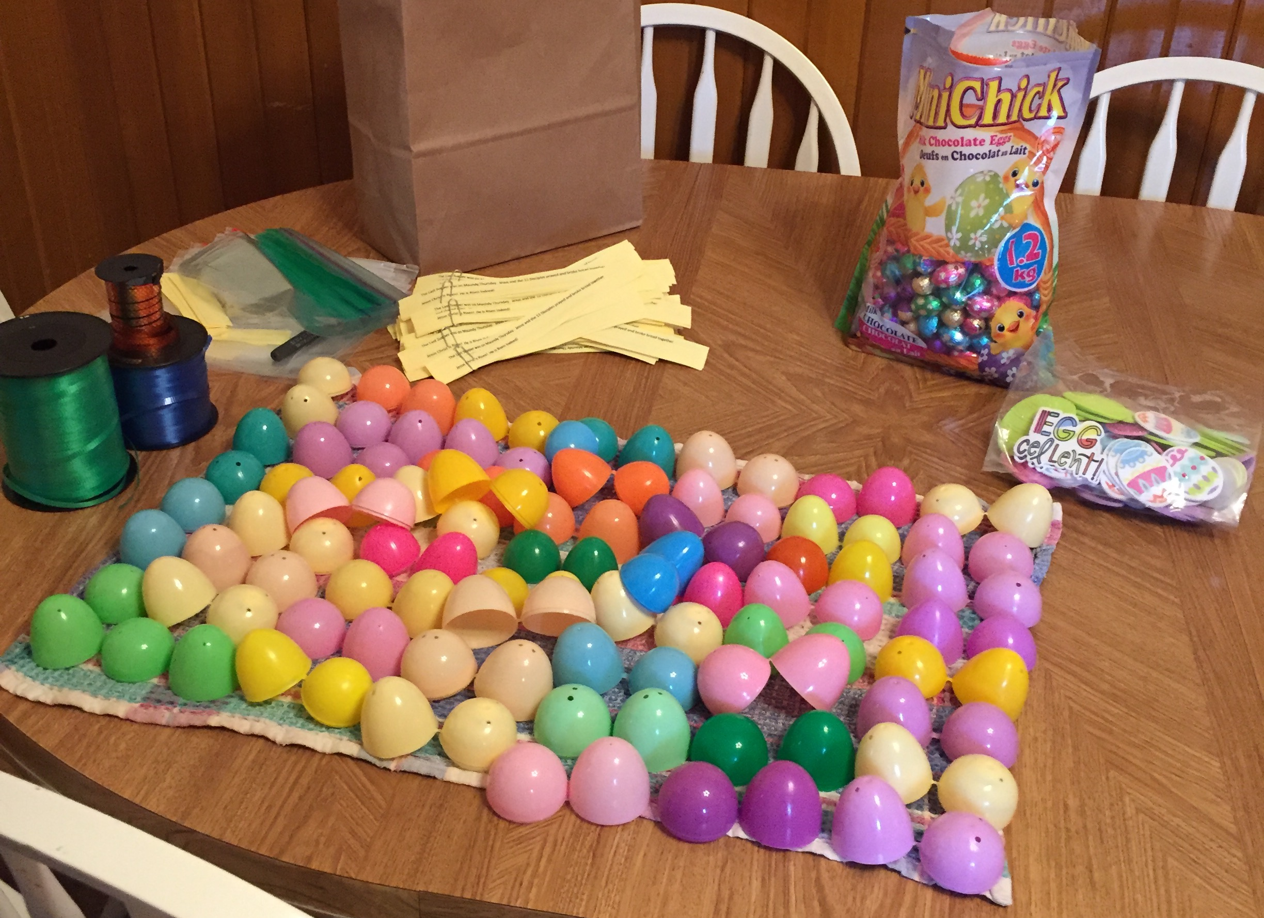
Gather Supplies
- Colourful fillable Easter eggs
- Chocolates & candies
- Anything kid-friendly and fun that will fit into the eggs: temporary tattoos, stickers, bouncy balls, erasers, small toys, friendship bracelets, buttons, key chains, stamps, etc.

If you are hosting this event as a church, ask people from the congregation to fill a dozen eggs and bring them to church the week before the hunt.

Setting Up
Whether you are having your hunt outside or indoors, ensure that the area you are using for the hunt is free of hazards and safe for young children. If you will have a wide range of ages, consider making two separate hunting areas (one for toddlers and one for the older kids). Or, in a shared hunting area, you could use different colour eggs for different age groups. For example, all of the pink and purple eggs could be for the little kids (hidden in easier spots, of course!) and the rest of the eggs, hidden in more challenging places, could be for the older kids.
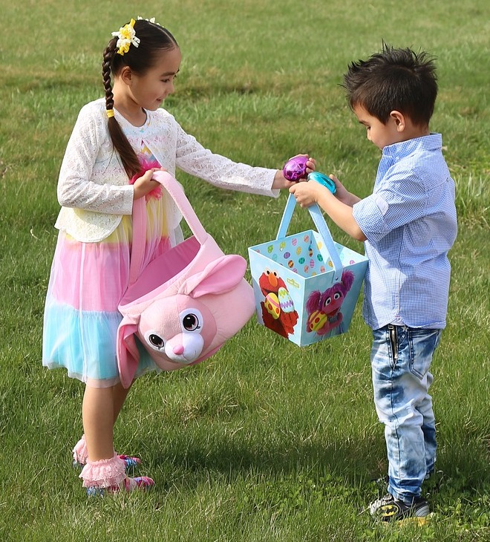
The Easter Egg Hunt
Warmly welcome your guests. Explain the rules and boundaries, and emphasize safety and fair play. Consider setting a maximum amount of eggs each child can collect to ensure that everyone gets a chance to gather some eggs. Set the kids loose in the hunting area until all of the eggs have been found.

Want to connect your Easter egg hunt to the Easter story?
Hide several “special” eggs (use sparkles, stickers, or paint to make these eggs stand out) that contain symbols and/or words related to the story of Easter. Number the outside of the eggs in order:
- Donkey (1)  - Palm branch (2)  - Bottle of Perfume (3)  - Water Pitcher & Towel (4)  - Bread & Grape Juice (5) | - Praying Hands (6)  - Sword (7)  - Cross (8)  - Nail (9)  - Angel (10)
At the end of the hunt, gather the children. Invite each child who found special eggs to the front to collect a prize. Open the eggs in order and use the image or words you find inside to tell the Easter story.

Consider incorporating the collection of these eggs into your worship service as a way to tell the story of Easter.

Extras
To make your Easter egg hunt extra special, consider including some of the following elements to your event:
- Pizza Lunch: Why not give parents a break from making lunch? Consider starting or ending your event with a pizza lunch.

- Craft table: No need to plan complicated crafts. Simply set up a table with lots of crayons and colouring pages. Click here to print some free Easter colouring pages.

- Sidewalk Chalk & Bubbles: If your hunt is outside, have sidewalk chalk and bubbles available for kids to play with and/or take home.

- Face painting: There are several beginner tutorials on YouTube that will teach you how to paint simple bunny and other Easter-themed patterns on faces.

Don’t forget to use the Easter Egg Hunt as an opportunity to invite participants to attend more family-friendly events and services at your church!

Include invitations to your Easter services with the invitations you deliver about the Easter Egg Hunt.

Be as welcoming as possible during the event. When appropriate, put forward a personal invitation to upcoming events and services.

Use the event as an opportunity to assess the needs of your community. Ask your neighbours how the church could serve them better. Create future events based on those needs.

